**VOCATIONAL TRAINING REPORT**

**URANIUM CORPORATION OF INDIA (UCIL)**





*For the month of 13 May -25 May, 2017*

At

***UCIL ( Narwapahar mines )***

**Submitted to :- Submitted by :-**

**Dr. S G Ishwar Ms. Kothapalli Suvanjali**

**GVTO, Narwapahar Mines Mr. Subham Sarkar**

**DEPARTMENT OF MINING ENGINEERING**

**INDIAN INSTITUTE OF TECHNOLOGY KHARAGPUR**

**WEST BENGAL**

Table of Contents Page no Date

Acknowledgements 01 22-05-2024

Abstract 02 22-05-2024

Literature Review 03-04 23-05-2024

Topic1: General mine safety and legislation ; 05-06 23-05-2024

Various laws governing mining industry ; to

Safety, Health and Environment. 27-05-2024

Topic 2: Uranium mine and geology, Mine plan 07-13 27-05-2024 to

Instruments in mine (Physics Department ) 29-05-2024

Topic 3: Mining methodology and practices in 14-25 30-05-2024

Different levels: 230mL , 275mL , 315mL to

Stowing , Blasting and Mine Ventilation 07-06-2024

Topic 4: Electrical Engineering and Mining 25-28 08-06-2024 to

Equipment 10-06-2024

Topic 5: Mechanical Engineering and Mining 28-38 11-06-2024 to

Machinery 12-06-2024

Topic 6: Radiological instruments 38-42 13-06-2024

Topic 7: References 42 13-06-2024

**Acknowledgement:**

I am deeply grateful to all those who provided me with the possibility to complete this internship project.

First and foremost, I would like to express my sincere gratitude to [**Mines Manager** **S.P.Tambad**], my internship supervisor at [**UCIL Narwapahar mine**], for their unwavering support, expert guidance, and valuable feedback throughout my internship. Their insights and advice were pivotal in the successful completion of this project.

I would also like to extend my heartfelt thanks to the entire Faculty at [UCIL Narwapahar], whose collaboration and support were essential in the execution of this project. Special thanks to [Staff members], whose expertise and assistance greatly contributed to my learning and the outcomes of this Training.

I am thankful to [**Dr. Debasis Deb**] and the faculty at [IIT Kharagpur], for their continuous support and for providing me with the foundational knowledge that was crucial for my internship. Their encouragement and academic mentorship have been invaluable.

Additionally, I wish to acknowledge [UCIL Narwapahar mine] for providing me with the opportunity to work on this project and for offering a conducive environment for learning and professional growth.

I am also grateful to my family and friends for their constant encouragement and understanding throughout the internship period. Their support was a source of strength and motivation.

Lastly, I would like to thank everyone who directly or indirectly contributed to the successful completion of this internship Training. Your support and encouragement have been greatly appreciated.

Thank you.

Kothapalli Suvanjali

Subham Sarkar

**01**

### Abstract:

This report documents the experiences and findings from my internship at Uranium Corporation of India Limited (UCIL) Narwapahar. The internship provided an in-depth understanding of uranium mining processes, operational safety, and environmental management practices at one of India's premier uranium mines.

The primary objective of the internship was to gain practical knowledge and hands-on experience in the various aspects of uranium mining, including extraction, processing, and waste management. Throughout the internship, I was involved in several key activities, such as site inspections, safety drills, and monitoring of environmental compliance.

The report begins with an overview of UCIL Narwapahar, highlighting its significance in India's nuclear energy sector. It then delves into the specific tasks and projects undertaken during the internship, including detailed descriptions of the methodologies employed and the technologies used in the mining operations.

Key findings from the internship include insights into the challenges of maintaining operational efficiency while ensuring stringent safety standards and minimizing environmental impact. The report also discusses the innovative practices implemented at UCIL Narwapahar to enhance sustainability and safety in mining operations.

In conclusion, the internship at UCIL Narwapahar was an invaluable learning experience that provided a comprehensive understanding of the practical challenges and solutions in the field of uranium mining. The knowledge gained and the skills developed during this period will significantly contribute to my future career in the mining and energy sectors.

**02**

**Literature Review: HISTORY OF URANIUM MINING IN INDIA**

Some forty-five years ago, when Dr. Bhabha initiated the development of nuclear energy, two decisions were taken; first was to construct CIRUS reactor and second was to work on production of uranium metal fuel in country. In year 1956, task of producing uranium metal was assigned to group called “Project Firewood”. For producing nuclear fuel it was necessary to search for the uranium deposit in country.

As early as in 1937 a sample of uranium is picked up by a prospector from one of copper mines in singhbhum thrust belt. In 1960, a close examination of this 160 km long mineral zone, out cropping on ridge of hill, which could be sizeable potential, was revealed at Jaduguda. This turned out to be major deposit and has remained best so far. In 1961, decision was taken to open up mine and mill and in 1967 Jaduguda mine has become full-fledged operational and is developed to depth to depth of 905m. The central shaft serves as entry for men and material and main ventilation intake route.

UCIL is committed to meet the increasing demand of Uranium in the country. The corporation aims to deepen the existing mines, expand its processing facilities, open new mines in the Singhbhum Shear zone and other parts of the Lambapur-Peddagattu & Tummalapalle in Andhra Pradesh and Kylleng-Pyndengsohiong, Mawthabah in Meghalaya. The coming years would thus see a quantum leap in UCIL's activities which would include not only opening  
new mines but also development of the community around all its operations.

Incorporated on 4th October 1967, Uranium Corporation of India Limited, a Public Sector Enterprise under the Department of Atomic Energy, is at the forefront of the Nuclear Power Cycle Fulfilling the requirement of Uranium for the Pressurised Heavy Water Reactors, UCIL plays a very significant role in India's Nuclear Power Generation Programme with five operating mines, two processing plants, a magnetite recovery plant. UCIL, an ISO 9001: 2000, ISO 14001: 2004 and IS 18001: 2000 company, has adopted the latest state-of-the-art technology for its mines and process plants. Enriched with in-house expertise and a team of dedicated professionals, UCIL can be truly termed as "Company with a mission”

**Narwapahar mine** is the first fully mechanized mine operating since April 1995. This is a trackless mine with a decline access to underground and ramp accesses to the stopes. This permits use of large diesel powered underground equipment

**03**

resulting in high productivity, eliminating fatigue of workmen and providing a good working environment. Diesel traction and Electro-hydraulic Drill Jumbos are used for drilling. The capability to drill long and parallel holes has improved drilling productivity. The mucking of blasted ore and waste is carried out by diesel powered Load – Haul – Dump Loaders and transported by Low – Profile – Dump – Trucks. To be able to utilize the high productive capacities of these machines, adequate back-up in terms of service vehicles such as passenger carriers, explosive vans, service and carriage trucks have been deployed. These make Narwapahar the most modern mine in India.

**India's uranium mines and mills - existing and announced:**

However, India has reserves of 290,000 tonnes of thorium - about one quarter of the world total, and these are intended to fuel its nuclear power program longer-term



**04**

**Topic1:**

**General mine safety and legislation; Various laws governing mining industry ; Safety, Health and Environment.**

### 1.General Mine Safety and Legislation

#### **Overview**

Mine safety encompasses a range of practices designed to protect miners from occupational hazards. It involves adherence to safety protocols, continuous training, and compliance with statutory regulations to mitigate risks in mining operations.

### 2. Various Laws Governing the Mining Industry

#### **Key Legislation and Compliance at UCIL Narwapahar**

**I.The Mines Act, 1952**

**Purpose:** Regulates labor and safety in mines, addressing working hours, employment conditions, and safety measures.

**UCIL Compliance:** Regular safety inspections, adherence to working hour regulations, and implementation of mandated safety protocols.

**II.The Mines Rules, 1955**

**Purpose:** Provides detailed safety standards, medical examinations, and welfare amenities for miners.

**UCIL Compliance:** Comprehensive safety training, periodic medical check-ups, and provision of welfare amenities as per the rules.

**III.The Mines Rescue Rules, 1985**

**Purpose:** Ensures preparedness for mine emergencies through the establishment of rescue stations and trained personnel.

**UCIL Compliance:** Maintenance of well-equipped rescue stations and regular training of rescue personnel.

**IV.The Coal Mines Regulations, 2017**

**Purpose:** Though primarily focused on coal mines, certain provisions apply to non-coal mines, covering mine plans, machinery, and equipment.

**UCIL Compliance:** Adherence to relevant regulations regarding mine planning and the use of certified machinery and equipment.

**05**

**V.The Atomic Energy Act, 1962**

**Purpose:** Governs the mining and processing of radioactive materials, ensuring safe handling and disposal of uranium.

**UCIL Compliance:** Strict protocols for handling and processing uranium, regular environmental monitoring, and compliance with disposal regulations.

**VI.The Environment (Protection) Act, 1986**

**Purpose:** Establishes measures for environmental protection and pollution control.

**UCIL Compliance:** Implementation of robust environmental management systems, pollution control measures, and regular environmental impact assessments.

### 3. Safety, Health, and Environment (SHE) Practices at UCIL Narwapahar

#### **Safety**

* **Risk Assessment:** Continuous risk assessments and hazard identification to mitigate potential dangers.
* **Accident Reporting:** A systematic approach to reporting and investigating accidents and near-misses.

#### **Health**

* **Medical Facilities:** On-site medical centers equipped to handle emergencies and conduct regular health check-ups.
* **Health Monitoring:** Ongoing monitoring of workers' health to identify and address occupational health issues early.

#### **Environment**

* **Environmental Management System:** Comprehensive management of environmental impacts, including waste management, water treatment, and land reclamation.
* **Sustainable Practices:** Initiatives such as tree planting, energy-efficient technologies, and pollution control to minimize environmental impact.

### Conclusion

My internship at UCIL Narwapahar provided significant insights into the practical application of mine safety and legislation. The adherence to comprehensive safety protocols, strict compliance with relevant laws, and the commitment to safety, health, and environmental management illustrate UCIL's dedication to sustainable and safe mining practices. This experience has greatly enhanced my understanding of the operational and regulatory frameworks within the mining industry.

.

**06**

**Topic 2:**

**Uranium mine and geology, Mine Instruments in mine (Physics Department)**

**GENERAL INFORMATION ABOUT MINE**

Name : Narwapahar Mine

Location : Latitude -22040’ N

Longitude : 86015’ E

Town : Jamshedpur

Post Office : Narwa mines

Railway station : Tatanagar railway station

District : East Singhbhum

Approximate life of mine : 50 yrs.

Average daily output : 1500 Tonnes

Number of lode present : 2

i.HANGWALL LODE

ii.FOOTWALL LODE

Both are being worked.

Most prominent and higher grade of ore is formed in footwall lode. Geological disturbances are at footwall side. Faults, folds, and joints are found at this side.

Depth Thickness and Inclination of Lodes:-

Name of lode Thickness Inclination

Footwall lode 5m-20m 450

Hangwall lode 3m-4m 450

Footwall lode confined to western side of shaft and also occurs in eastern side of shaft. It is completely uniform and no disturbances are found.

Width increases due to low angle strike fall along which molybdenum mineralisation has taken place. Rock fall occurs in western side due to molybdenum. In centre portion of Narwapahar epidorite interveins the strata hence causes ore loss.

**07**

**GEOLOGY OF NARWAPAHAR MINE:**

# INTRODUCTION

**Narwapahar mine** is the first fully mechanized mine operating since April 1995. This is a trackless mine with a decline access to underground and ramp accesses to the stopes. This permits use of large diesel powered underground equipment resulting in high productivity, eliminating fatigue of workmen and providing a good working environment. Diesel traction and Electro-hydraulic Drill Jumbos are used for drilling. The capability to drill long and parallel holes has improved drilling productivity.

## GENERAL GEOLOGY

Uranium mineralisation in Narwapahar is confined to sheared rock types of Singbhum Thrust Zone. Geologically, the thrust belt is constituted by Archean metasediments such as mica-schist, quartzite, phyllites and altered tuffs. The rocktypes in this zone are broadly classified into two groups – the older Chaibasa stage of rocks consisting of meta-sediments and the younger Dhanjori stage of rocks consisting of metavolcanics.

During shearing, the older Chaibasa stage of rocks is thrust over younger metavolcanics of Dhanjori. As a result, the younger Dhanjori stage of rocks lie below the older Chaibasa stage of rocks. The thrust contact between two stages of rocks is severely sheared and brecciated. Uranium occurs in this sheared zone in very finely disseminated form.

## OREBODY CONFIGURATION

Mineable mineralisation at Narwapahar is confined to two principal lodes – known as Footwall Lode (FWL) and Hanging wall Lode (HWL) - extending as veins following the general trend of the schistosity. Persistence of lodes is fairly uniform both along strike and dip with an average inclination of about 400. Both the lodes are parallel and separated from each other by a distance of about 80m.

**08**

**MINERALOGY:**

The primary uranium minerals in Narwapahar are uraninite and pitchblende. The common secondary uranium mineral is autonite. The uranium minerals are associated with a wide variety of sulphides of copper, nickel, cobalt, molybdenum, arsenic, bismuth. Apatite and magnetite are common associates and found as high as 10% to 15% at places.

## PROMINENT STRUCTURAL FEATURES

The principal planar structures in Narwapahar mine are foliation planes, joint planes and shear planes.

The foliation planes are the dominant planar feature in the mine. Since these planes do not show any abrupt anisotropy, they do not affect the stability of rock.

There are three sets of joint planes present in the rocks.

J1 - The most prominent one is nearly parallel to foliation strike but having dip 300 to 400. A few of them are nearly vertical.

J2 - The second set of joints are the dip joints which are vertical or having dip 300 to 450.

The principal shear planes are confined to western side only. These are the low angle strike-slip shears mineralised with molybdenum nearly parallel to the foliation dip and makes an angle of 150 to 200 with the foliation strike of the rock. The width of this zone varies from few mm to 80mm.

Of the above planar features, the molybdenum shear plane, J1 and J2 are treated as discontinuity planes (from geo-technical point of view). These planes, in combination, create some unstable blocks specially in the western section of the mine.

**09**

## **PHYSICO-MECHANICAL PROPERTIES:**

In Narwapahar mine, the host rock and the adjoining strata are quite competent except the talc-chlorite schist zone in the footwall side.

The increasing trend of uniaxial compressive strength of rocks with depth indicates better competency and self-supporting nature of rock.

Some other physico-mechanical properties of rocks have also been studied at different depth.

The values are given as follows.

|  |  |  |
| --- | --- | --- |
| **PROPERTIES** | **140ML** | **295ML** |
| DENSITY | 2.85 g/cm2 | 2.78g/cm2 |
| MOISTURE CONTENT | 0.143% | 0.31% |
| COHESIVE STRENGTH | 146.66kg/cm2 | 162.5kg/cm2 |
| ANGLE OF INTERNAL FRICTION | 400 | 42.50 |
| YOUNG’S MODULOUS | 115384.5kg/cm2 | 183333.3kg/cm2 |
| POISSION’S RATIO | 0.335 | 0.210 |
| POROSITY | 1.7% | 1.7% |
| PERMEABILITY | 0 | 0 |

### Instruments Used for Detecting Ore at UCIL Narwapahar

At UCIL Narwapahar, various sophisticated instruments and techniques are employed to detect and evaluate ore deposits. These instruments ensure accurate and efficient exploration and mining operations. The following are the key instruments and their detailed descriptions:

#### 1. **Geophysical Survey Instruments**

**10**

**a. Magnetometers:**

* **Purpose:** Used to measure the magnetic properties of rocks and minerals.
* **Function:** Magnetometers detect variations in the Earth's magnetic field caused by the presence of magnetic minerals such as magnetite. This helps in

mapping geological structures and identifying ore bodies.

* **Types:**
  + **Proton Precession Magnetometers:** Measure the frequency of protons in a magnetic field.
  + **Fluxgate Magnetometers:** Detect the direction and strength of the magnetic field using a core of magnetically susceptible material.

**b. Electromagnetic (EM) Instruments:**

* **Purpose:** Used to measure the conductivity of the subsurface.
* **Function:** EM instruments generate electromagnetic fields and measure the response from the ground. Conductive materials, like sulfide ore bodies, create distinct anomalies.
* **Types:**
  + **Time-Domain EM Systems:** Measure the decay of the secondary magnetic field over time.
  + **Frequency-Domain EM Systems:** Measure the amplitude and phase shift of the secondary field at different frequencies.

**c. Induced Polarization (IP) Instruments:**

* **Purpose:** Used to detect disseminated sulfide minerals.
* **Function:** IP instruments measure the ability of the subsurface to temporarily hold an electric charge. Sulfide minerals cause a chargeability response that can be measured to identify ore zones.
* **Equipment:** IP surveys typically use a transmitter to inject current into the ground and a receiver to measure the voltage decay.

#### 2. **Geochemical Analysis Instruments**

**a. Portable X-ray Fluorescence (XRF) Analyzers:**

* **Purpose:** Used for rapid in-field analysis of elemental composition.
* **Function:** XRF analyzers direct X-rays at a sample, causing it to emit secondary (fluorescent) X-rays. The wavelengths of these X-rays are characteristic of specific elements, allowing for their identification and quantification.

**11**

* **Advantages:** Non-destructive, fast, and capable of analyzing a wide range of elements.

**b. Atomic Absorption Spectrometers (AAS):**

* **Purpose:** Used for analyzing metal concentrations in samples.
* **Function:** AAS instruments atomize the sample and measure the absorption of light at specific wavelengths by free atoms. This absorption indicates the presence and concentration of metals.
* **Applications:** Used extensively in laboratory settings to analyze rock, soil, and water samples.

#### 3. **Remote Sensing and GIS Technology**

**a. Satellite Imagery and Aerial Photography:**

* **Purpose:** Used for large-scale geological mapping and mineral exploration.
* **Function:** Remote sensing involves capturing images of the Earth's surface using satellites or aircraft. These images are analyzed to identify surface features and alterations indicative of mineral deposits.
* **Applications:** Helps in identifying areas of interest for detailed ground surveys.

**b. Geographic Information Systems (GIS):**

* **Purpose:** Used for managing, analyzing, and visualizing spatial data.
* **Function:** GIS integrates various data sets, including geological maps, geophysical survey results, and geochemical data, to create comprehensive models of the subsurface.
* **Advantages:** Enhances decision-making and planning in exploration projects.

#### 4. **Drilling and Sampling Equipment**

**a. Diamond Core Drills:**

* **Purpose:** Used for obtaining continuous core samples from the subsurface.
* **Function:** Diamond-tipped drill bits cut through rock to extract cylindrical core samples. These samples provide valuable information on the geology and mineralization of the ore body.
* **Applications:** Core samples are analyzed for mineral content, structure, and other geological properties.

**b. Reverse Circulation (RC) Drills:**

* **Purpose:** Used for obtaining rock chip samples from the subsurface.

**12**

* **Function:** RC drilling uses dual-walled drill rods to transport rock chips to the surface using compressed air. This method is faster than core drilling and suitable for initial exploration.
* **Advantages:** Provides a quick and cost-effective way to obtain subsurface samples.

### Conclusion

The detection and evaluation of ore deposits at UCIL Narwapahar involve a combination of advanced geophysical, geochemical, and remote sensing instruments. Each instrument plays a crucial role in providing accurate and detailed information about the subsurface, enabling effective exploration and mining operations. By utilizing these sophisticated tools, UCIL ensures efficient resource management and sustainable mining practices.

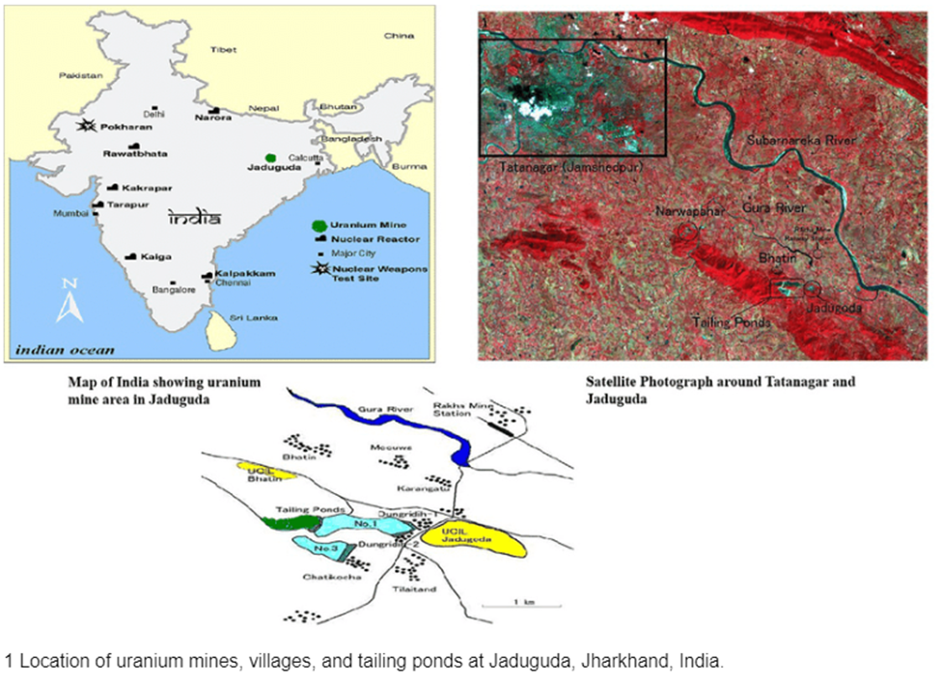

**13**

**Topic 3:**

**Mining methodology and practices in Different levels: 230mL, 275mL , 315mL, Stowing , Blasting and Mine Ventilation.**

**Method of Mining**

Underground Mining: Existing & Proposed Mining Method At Narwapahar Horizontal Cut and Fill (HCF) method of mining is practiced. HCF is a method to excavate one slice of ore and filling back the same by waste rock, mill tailings etc. This fill forms the platform for men and machinery to work on to excavate the next slice. The slices are taken from lower level to the upper level leaving requisite sill pillar to for the upper level. The same method is also proposed to be continued during the rest of life of the mine.

The mine works 300 days / year. Narwapahar mine is a highly mechanized underground mine with entry through 7o decline and vertical shaft. Old inclines serve as second outlets since it is commissioned with effect from year 1995. Latest technology of trackless mining system has been adopted in this mine with decline as mine entry and ramps for access in stopes. ROM and waste are hauled up by trackless method using ST/MT (LHD/LPDT) combination and subsequently by skip hoisting system through shaft. The various underground equipments used in the mine are Drill Jumbos, LPDTs, LHDs, service Transport vehicles like Supply Truck, Service Truck, Passenger Carrier, Road Grader, Scissor Lift and Explosive Van. Other underground auxiliary equipments are pumps, auxiliary fans, jack hammer drill machine, diamond drill machine etc. The various surface equipments are winders, main mechanical ventilation fans, compressors, dozer, payloader, various transport vehicles, workshop equipments, D.G. set for emergency power etc. Mining of ore is done by cut and fill method of under ground mining. Sand stowing is practiced to fill the voids created by excavation. The ore is transported by dumpers to Jaduguda Process Plant. The major part of waste rock is used for backfilling of voids in underground workings and only small portion is brought to surface. Such waste rock is dumped at designated area, acquired for the project. Mine discharge water is collected at 140 ML and pumped to the surface. Adequate capacity of pumping arrangement has been installed which take care of higher seepage of rain water. Total

installed capacity of pump at underground is 900 m3 /hr (120 m3 /hr - 3 nos. and 90

**14**

m3 /hr- 6 nos.). Under the expansion pumping shall be carried out in stages the pump chambers shall be constructed at 275 ml, 415 ml and 555 ml. At Narwapahar mine, production of uranium ore commenced in 1995 – 96. The production in 1995 – 96 during the first year was 95000 t. Since then the production has gradually increased to about 400,000 t/yr. The year-wise productions of ore from Narwapahar Mine have not been furnished in this report as the same is classified as “Restricted Information” as per Section 3 of the Atomic Energy Act, 1962.

**Mine Design Parameters**

• Cross section of drive, drift and cross cuts will be 5.5 m X 3.5 m.

• During jumbo drilling, depth of hole will be 3.2 m to get a pull of 3.0 m

• Back support by rock-bolting at 2 m x 2 m grid pattern. However, this pattern varies with experience.

**Mode of entry (Adit/incline/shaft/decline)**

Decline of size 5 m X 3.5 m size at 70 inclination from surface for flexible movement of all trackless diesel equipment is in use. Presently decline has been excavated up to 250 mRL and will be driven further to lower levels for faster development and transportation of waste muck to upper level for back filling in stopes. Vertical shaft of 5m finished diameter up to a depth of 355.3 m from surface is in use. Vertical shaft is concrete lined for entire depth and connected to 100 mRL, 140 mRL, 185 mRL, 230 mRL, 275 mRL, 295 mRL (crushing chamber) and 315 mRL (loading point). The shaft houses the cage, the skip, and counter weights. It is proposed to construct a new vertical shaft of 700 meter depth as the present vertical shaft cannot hoist more than 1500 tpd. Also the hoisting depth of present shaft is limited to 315 meter depth upto VIII Level only. The mine section is shown Fig1.

**15**

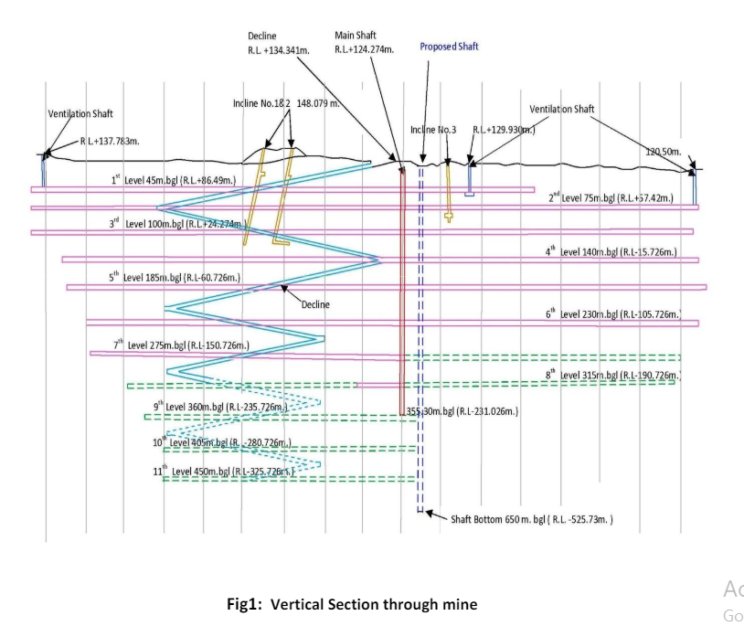

**Underground Layout**

The mine is accessed by 70 and a vertical shaft. Horizontal cut & fill method is being adopted for exploitation of ore and same is proposed to be continued in near future. Presently 12 nos. of stopes are in operation, out of this 6 stope is under production, 3 stopes are under stowing and 3 stopes are under preparation for stowing. Out of present 1500 t/d ore, 1200 t/d is produced from 6 nos. of stopes and 300 tpd ore is from development faces. About 400 t/d of waste rock is generated from development works. It is proposed to develop more stopes to increase the production. Total 16 stopes shall be required. 8 stopes shall be under production and 4 stopes each under stowing and other preparatory jobs. The stoping activities will produce 1500 tpd and rest 500 tones shall be produced from development faces. Rock bolt system is being practiced to support the rock wherever necessary. The spacing of the rock bolts are determined on case to case basis based on the experience acquired on the rock strength during the operation of the mine.

**Method and sequence of stoping**

The sequence of operation followed at Narwapahar for the horizontal cut and fill

**16**

method are as follows:

• Since, the ore body at Narwapahar is lenticular and is of irregular shape in horizontal as well as vertical directions, it is necessary to define stope extremities establish the exact ore geometry before regular slices can be taken.

• The ore drive, approximately 5.0 m X 3.2 m is developed along the footwall contact from one end of the proposed stope block to other end along the strike. Often each stope is a distinct ore lens and the above development of ore drive establishes the length and behavior of the ore body at the level. Ore drives are developed in similar manner at the upper and the lower levels.

• The ore drives as developed above are widened to expose the hangwall subject to a maximum width of 10.5 m. Above this width regular 4 m X 4 m pillars are left in the dip direction systematically. This establishes the exact width of the ore body in the proposed stope block.

• The drift along the strike and in footwall rock approximately 20 m to 40 m away from footwall contact of the ore body is developed. This follows the development of the ore drive maintaining a lag of about 50 m. This is done to provide permanent access to the level and serves as the hauling roadway as the ore drives get filled on commencement of stoping operations.

• At both extremities of the proposed stoping block, raises are put up to connect the lower level to the upper level.

• A ramp is developed in ore/footwall rock either from upper level to lower level or from lower level to upper level or a combination of the two to provide access for the trackless equipments like Jumbos & LHDs to the stope.

• The back of the ore drive is stripped up to a height of 5 m to provide access to Physics and Geology personnel to establish the vertical geometry of the ore body. The above completes the development and stoping commences by cyclic slicing and filling. This progresses from the lower level to the upper level. The schematic method of mining is illustrated as Figs. 2, 3 and 4

**17**

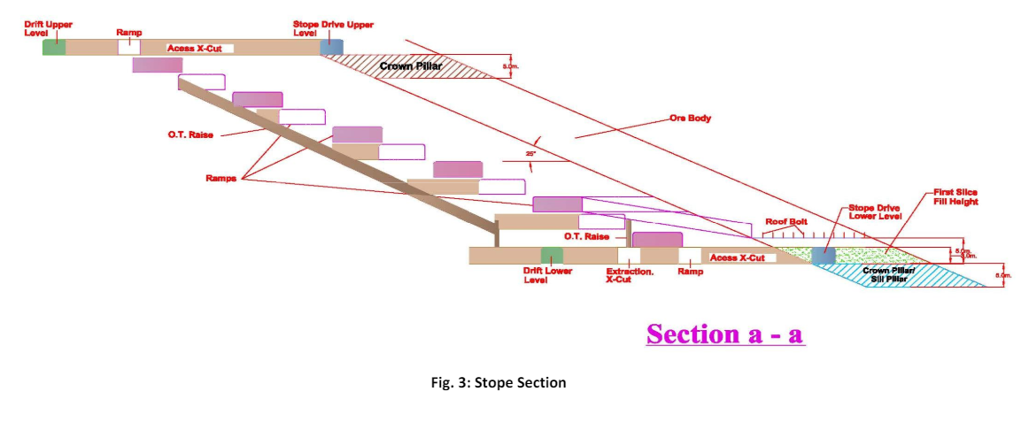

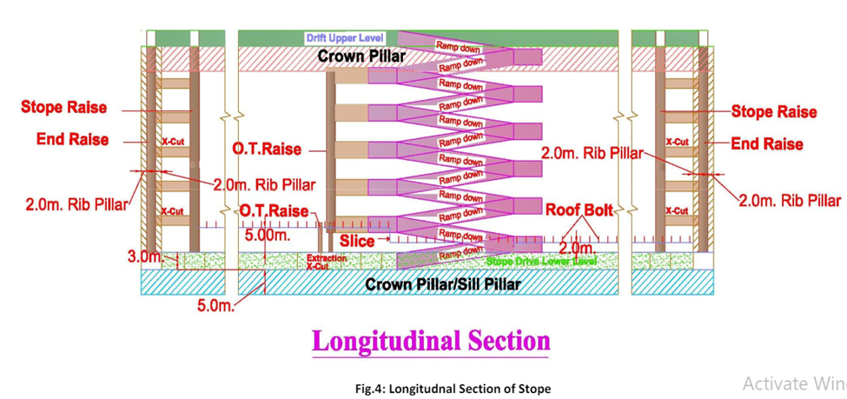

**18**

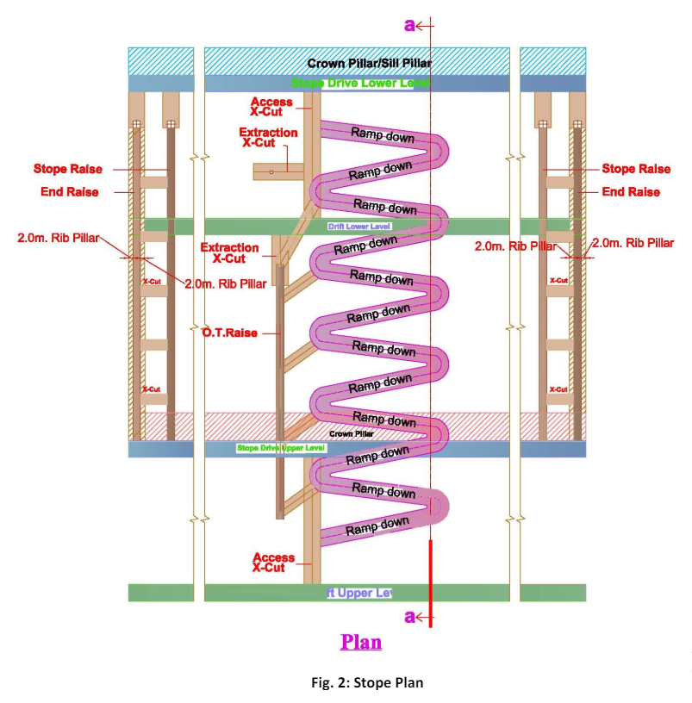

**19**

### Stowing Process at UCIL Narwapahar

**Purpose:** The primary purpose of stowing at UCIL Narwapahar is to prevent surface subsidence in shallow mining areas. Surface subsidence can lead to environmental degradation and structural damage to nearby infrastructure. Stowing helps maintain ground stability and ensures the safety of mining operations.

**Types of Stowing:** There are several types of stowing used in mining operations:

1. **Hydraulic Stowing:** Involves pumping a slurry of sand and mill tailings into the voids.
2. **Pneumatic Stowing:** Uses air pressure to blow dry materials into the mine voids.
3. **Mechanical Stowing:** Involves using mechanical equipment to transport and place stowing materials.
4. **Manual Stowing:** Done manually, usually in smaller mines or specific areas.

**Hydraulic Stowing Process at UCIL Narwapahar:** UCIL Narwapahar primarily uses hydraulic stowing due to its effectiveness and efficiency. The process involves the following steps:

1. **Material Collection:**
   * Mill tailings, which are the by-products of ore processing, are collected from the Jaduguda mill.
   * Sand is sourced from nearby rivers or other suitable locations.
2. **Slurry Preparation:**
   * The collected sand and mill tailings are mixed with water to create a slurry. The mixing ratio is carefully controlled to ensure the right consistency and properties for effective stowing.
3. **Transportation:**
   * The slurry is transported to the mine through a network of pipelines. This pipeline system is designed to handle the abrasive nature of the slurry and maintain a continuous flow.
4. **Pumping:**
   * High-capacity pumps are used to inject the slurry into the underground voids created by mining operations. These pumps must be robust and capable of handling the high-pressure requirements to ensure the slurry reaches the intended locations.

**20**

* + The slurry is pumped into the voids through boreholes drilled from the surface or from within the mine.

1. **Filling the Voids:**
   * The slurry fills the voids left by the extracted ore. As the slurry settles, the water is drained off, leaving behind a solid mass of sand and tailings that provide structural support.
2. **Monitoring and Maintenance:**
   * The stowing process is continuously monitored to ensure even distribution and proper filling of the voids. Regular inspections and maintenance of the pumps and pipelines are conducted to prevent blockages and ensure efficient operation.

**Advantages of Hydraulic Stowing:**

1. **Efficient Waste Utilization:**
   * Utilizes mill tailings, reducing the need for waste disposal and minimizing environmental impact.
2. **Subsidence Prevention:**
   * Reduces the risk of surface subsidence, protecting buildings, roads, and natural features above the mine.
3. **Enhanced Safety:**
   * Improves ground stability, reducing the risk of collapses and enhancing the overall safety of mining operations.
4. **Environmental Protection:**
   * Minimizes environmental disturbances by stabilizing the ground and preventing the formation of sinkholes and other surface deformations.

**Conclusion:** Hydraulic stowing at UCIL Narwapahar is a critical process that ensures the safety and stability of the mining operations. By efficiently using waste materials and preventing surface subsidence, UCIL demonstrates a commitment to sustainable mining practices and environmental stewardship. The use of advanced pumping systems and continuous monitoring ensures the effectiveness of the stowing process, maintaining the integrity of the mine structure and protecting the surrounding environment.

**21**

### Drilling and Blasting at UCIL Narwapahar

#### Overview

Narwapahar is a mechanized hard rock mine where rock excavation is performed using conventional drilling and blasting methods. This approach is essential for breaking and removing rock to access the ore bodies. The mine employs two primary blasting patterns depending on the specific mining activity: the inverted ‘V’ pattern for slice blasting in stopes and the burn cut pattern for development headings.

#### Blasting Patterns

1. **Inverted ‘V’ Pattern for Slice Blasting:**
   * **Application:** Used in stopes, which are the underground openings where ore is extracted.
   * **Pattern Description:** The inverted ‘V’ pattern is designed to efficiently break the rock in a controlled manner. The placement of the drill holes forms an inverted ‘V’ shape.
   * **Explosive Consumption:** On average, 150-160 kg of explosive is used to break a rock mass with dimensions of 2.8 meters (height) x 8.4 meters (width) x 3.2 meters (depth).
   * **Powder Factor:** The average powder factor, which is the amount of explosive required to break a ton of rock, is estimated at 0.53 kg/t. This indicates that 0.53 kg of explosive is needed to break one ton of rock.
2. **Burn Cut Pattern for Development Headings:**
   * **Application:** Used in development headings, which are the tunnels and passages created to access the ore bodies.
   * **Pattern Description:** The burn cut pattern is designed to initiate the breakage from the center of the face and propagate outwards. This method creates an initial void that allows subsequent explosions to break the surrounding rock more efficiently.
   * **Explosive Consumption:** The specific quantity of explosive used per blast can vary, but the powder factor achieved with the burn cut pattern is higher than that of the inverted ‘V’ pattern.
   * **Powder Factor:** The average powder factor for burn cut blasting is around 1.02 kg/t. This means that 1.02 kg of explosive is required to break one ton of rock, indicating a more intensive use of explosives compared to the inverted ‘V’ pattern.

#### Blasting Details

**1. Drill Hole Placement:**

* Drill holes are strategically placed in specific patterns to ensure effective rock breakage.
* The drill holes are loaded with explosives and detonators.

**22**

**2. Explosive Types:**

* Various types of explosives are used, including ANFO (Ammonium Nitrate Fuel Oil), emulsions, and dynamites, depending on the rock type and blasting requirements.
* The choice of explosive is based on factors such as rock hardness, desired fragmentation, and safety considerations.

**3. Detonation Sequence:**

* The detonation sequence is carefully planned to control the direction of the blast and optimize rock fragmentation.
* Delayed detonators are used to initiate the explosions in a specific order, ensuring that the rock breaks progressively and reduces the risk of fly rock and excessive vibration.

**4. Safety Measures:**

* Comprehensive safety protocols are followed to protect workers and equipment during blasting operations.
* Blast guards and warning signals are used to clear the blast area and alert personnel.
* Monitoring equipment is used to measure blast vibrations and ensure they are within safe limits.

**5. Post-Blast Procedures:**

* After the blast, the broken rock is mucked (removed) using mechanized loaders and haulage systems.
* The blasted area is inspected for safety and stability before mining operations resume.

#### Conclusion

Drilling and blasting are critical components of the mining process at UCIL Narwapahar. The use of the inverted ‘V’ pattern for slice blasting and the burn cut pattern for development headings ensures efficient rock breakage and access to the ore bodies. By optimizing the powder factor and following stringent safety measures, UCIL Narwapahar achieves effective and safe rock excavation, contributing to the overall productivity and sustainability of the mining operations.

**Ventilation System Components:**

1. **Primary Ventilation:**
   * **Main Fans:** Large, powerful fans installed at the surface to push fresh air into the mine or pull air out, creating a flow of air through the entire mine.
   * **Air Shafts:** Vertical or inclined passages that connect the surface with the underground workings, allowing for the movement of air.

**23**

1. **Secondary Ventilation:**
   * **Auxiliary Fans:** Smaller fans used within the mine to direct air to specific areas where workers are active. These fans help in distributing air to working faces and other remote areas.
   * **Ducts and Tubing:** Flexible or rigid tubes used to channel air from the main ventilation system to specific locations within the mine.
2. **Ventilation Controls:**
   * **Air Regulators:** Adjustable barriers or doors that control the flow and direction of air within the mine.
   * **Ventilation Doors:** Installed in roadways to control and direct the airflow. They can be opened or closed to manage the air distribution.
   * **Brattices:** Temporary partitions made of cloth or plastic used to direct airflow in specific directions.

**Ventilation Practices:**

1. **Airflow Management:**
   * Fresh air is continuously supplied to all working areas, ensuring that harmful gases like methane, carbon monoxide, and diesel exhaust are diluted and removed.
   * The airflow rate is monitored and adjusted based on the number of workers, the type of work being performed, and the presence of any hazardous gases.
2. **Gas Monitoring:**
   * Regular monitoring of gas levels is conducted using gas detectors and sensors placed at strategic locations throughout the mine.
   * Alarms and automatic shut-off systems are in place to warn workers and stop equipment if dangerous gas concentrations are detected.
3. **Temperature Control:**
   * Ventilation systems help in controlling the temperature within the mine, preventing overheating and ensuring a comfortable working environment.
   * In deeper sections of the mine where temperatures can rise significantly, cooling systems may be employed to maintain acceptable temperature levels.
4. **Dust Control:**
   * Ventilation systems also play a role in controlling dust levels by providing adequate airflow to disperse and remove dust particles generated during mining operations.
   * Additional dust suppression measures, such as water sprays and dust collectors, are used in conjunction with ventilation to maintain air quality.  **24**

**Safety Measures:**

1. **Emergency Ventilation:**
   * Backup fans and power supplies are available to ensure continuous ventilation in case of power failures or other emergencies.
   * Emergency escape routes are equipped with ventilation systems to provide safe passage for workers during evacuations.
2. **Ventilation Planning:**
   * Detailed ventilation plans are developed and regularly updated to account for changes in the mine layout and working conditions.
   * Computer simulations and modeling are used to design and optimize the ventilation system for maximum efficiency and safety.

**Conclusion:**

Ventilation at UCIL Narwapahar is a critical aspect of mine operations, ensuring the health and safety of workers by providing fresh air, controlling gas levels, and maintaining suitable temperature and dust conditions. The use of advanced ventilation techniques and continuous monitoring ensures a safe and productive working environment in the mine

**Topic:4**

### Electrical Engineering and Mining Equipment at UCIL Narwapahar

**Overview:** UCIL Narwapahar integrates various electrical engineering principles and sophisticated mining equipment to ensure efficient, safe, and productive mining operations. This includes power supply and distribution, automation, and control systems, and specialized mining machinery.

**Key Areas:**

1. **Power Generation and Distribution:**
   * **Power Supply:** The mine requires a stable and continuous power supply, primarily generated on-site using diesel generators or potentially renewable energy sources like solar panels. This ensures that all mining equipment and systems can operate without interruption.
   * **High-Voltage Distribution:** Power is distributed across the mining site through high-voltage transmission lines, which connect to substations and transformers to step down the voltage for use in various equipment and facilities.
2. **Mining Equipment:**
   * **Drilling Machines:** Electric drills are used for creating blast holes in rock. These machines are crucial for the initial phase of rock breakage and ore extraction.

**25**

* + **Blasting Equipment:** Electric initiation systems are used to precisely control the timing and sequence of blasts, improving safety and efficiency.
  + **Excavators and Loaders:** Large electric-powered excavators and loaders are employed to move rock and ore. These machines offer advantages over diesel-powered alternatives, including lower emissions and operational costs.

1. **Automation and Control:**
   * **PLC (Programmable Logic Controllers):** These controllers automate processes such as drilling, blasting, and ore transport. They ensure precision and safety by monitoring and controlling machinery operations.
   * **SCADA (Supervisory Control and Data Acquisition) Systems:** SCADA systems are used for remote monitoring and control of mining operations. They gather data from various sensors and equipment, providing real-time information and control capabilities from a central location.
   * **Autonomous Equipment:** Increasingly, UCIL may be integrating autonomous trucks, drills, and loaders that can operate without direct human intervention, improving safety and efficiency.
2. **Safety Systems:**
   * **Grounding and Bonding:** Essential for preventing electrical shocks and ensuring the safe operation of all electrical equipment, especially in the humid and conductive underground environment.
   * **Explosion-Proof Equipment:** Electrical equipment used in areas with a high risk of explosive gases must be explosion-proof to prevent ignitions. This involves specially designed enclosures and components.
   * **Emergency Power:** Backup power supplies, including batteries and secondary generators, ensure that critical systems remain operational during power outages.
3. **Ventilation Systems:**
   * **Main Fans and Auxiliary Fans:** Electrically powered fans are crucial for maintaining air quality and temperature control. Main fans handle large volumes of air, while auxiliary fans direct air to specific work areas.
   * **Monitoring Equipment:** Sensors and control systems continuously monitor air quality, gas levels, and airflow, ensuring a safe environment for miners.

**26**

1. **Maintenance and Reliability:**
   * **Predictive Maintenance:** Using data from sensors and monitoring systems, predictive maintenance strategies help identify potential equipment failures before they occur, reducing downtime and maintenance costs.
   * **Condition Monitoring:** Regular checks and monitoring of electrical systems ensure that equipment operates reliably and efficiently, preventing unexpected breakdowns.

**Advanced Technologies:**

1. **Electric and Hybrid Vehicles:**
   * **Electric Trucks and Loaders:** The use of electric vehicles reduces emissions and operational costs, contributing to a more sustainable mining operation.
   * **Hybrid Systems:** Combining electric and diesel power in hybrid vehicles can offer improved fuel efficiency and reduced environmental impact.
2. **Energy Storage Systems:**
   * **Battery Storage:** Advanced battery systems store energy generated from renewable sources or during off-peak periods, ensuring a steady power supply and reducing reliance on diesel generators.
3. **Renewable Energy Integration:**
   * **Solar and Wind Power:** Integrating renewable energy sources helps reduce the carbon footprint and operational costs. Electrical engineering is vital for designing systems that effectively combine renewable and traditional power sources.

**Specific Equipment Examples:**

1. **Electric Drills and Blasting Machines:**
   * **Function:** Create precise blast holes for rock breakage.
   * **Control:** Automated control systems ensure accurate drilling patterns and optimal blast sequences.
2. **Electric-Powered Loaders and Haul Trucks:**
   * **Function:** Move ore and waste rock efficiently.
   * **Benefits:** Lower operational costs and emissions compared to diesel-powered equipment.
3. **Conveyor Systems:**
   * **Function:** Transport ore from the mining face to processing facilities.
   * **Control:** Automated systems monitor and control the speed and operation of conveyors to optimize efficiency.

**27**

**Conclusion:**

Electrical engineering plays a vital role in the operation of UCIL Narwapahar, from providing reliable power and ensuring safety to enhancing the efficiency and sustainability of mining equipment. By integrating advanced technologies and automation systems, UCIL can maintain high standards of productivity, safety, and environmental stewardship in its mining operations.

**Topic:5**

**Mechanical Engineering and Mining Machinery:**

**MINING MACHINERY USED IN MINES**

* **AXERA DO5-126 [H] (also called jumbo or boomer)**

Make – Sandvik TAMROCK

Technical specifications-

* + Length : 11420 mm
  + Width : 1750 mm
  + Height : Roof down : 2100 mm

Roof up : 3020 mm

* Turning radius : 5220/2980 mm
* Tramming speed : 12 Kmph (horizontal)

5 KMPH (at 80)

* Noise level : <98 dB(A)
* Weight : 11000 kg
* Electrical motor : 45 kW (60 hp)
* Boom type : parallel holding
* Feed roll-over : 3600
* Boom extension : 1200 mm
* Drill rod assembly length : 3.7 m
* Depth of hole drilled : 3.4 m
* Impact power : 16 kW

Tyre specifications : Rubber tyres, radial type,

**28**

Width to rim radius ratio : (12-20)

Time taken by jumbo in drilling : 2.5 min (approx.)

Telescopic boom of jumbo can feed up to 1700 mm.

* **BOLTEC**

Model : Boltec 235

Make : Atlas-Copco

Power : 55 kW

RPM : 2500 rpm

Max torque : 230 N-m @ 1550 rpm

Transmission type : hydro dynamic

Drill rod length : 2.7 m

Hole depth : 2.4 m

**VARIOUS COMPRESSORS**

|  |  |  |  |  |  |
| --- | --- | --- | --- | --- | --- |
| **Compressor** | **No. 01** | **No. 02** | **No. 03** | **No. 04** | **No. 05** |
| **Make** | K.G.Khoshla | K.G.Khoshla | K.G.Khoshla | Atlas Copco | Atlas Copco |
| **Capacity** | 535 C.F.M | 535 C.F.M | 535 C.F.M | 960C.F.M | 960C.F.M |
| **Working Pressure** | 7.0kg/cm2 | 7.0kg/cm2 | 7.0kg/cm2 | 7.0kg/cm2 | 7.0kg/cm2 |
| **Electric Motor** | 120KW | 93KW | 120KW | 200KW | 200KW |
| **Date of Commissioning** | 2/3/1986 | 2/3/1986 | 2/3/1986 | 21/3/1990 | 26/6/1998 |
| **Reciprocating** | Two Stage | Two Stage | Two Stage | Screw single stage | Screw single stage |

6600 Volts are used in this compressor.

**29**

**LOADING MACHINES**

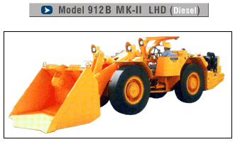

**Features:**

* Payload - 4000 Kgs
* Breakout force - 6700 Kgs (DIGGING) and 11890 Kgs (HYD. COMBINED)
* Type of engine - Deutz F6L 912W
* Compact in size with short turning radius.
* Short loading and tramming cycles.
* Spacious operator compartment on rear chassis at articulation.
* Unique articulation joint and rear axle oscillation for minimum downtime.
* Full power shift Transmission.
* No spin on both front and rear axles.
* High dumping height for easy truck loading.
* Modulated clutch for reduced shocks and drive train stress.
* Pilot operated controls for reduced fatigue and increased productivity.
* Simple 24V Electric system for ease of maintenance.

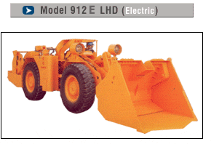

**30**

**Features:**

* Higher payload for increased productivity.
* High tilt, combination and mechanical breakout force for efficient and single pass loading.
* Fingertip controls for reduced fatigue, higher productivity and safety of operator.
* High tractive efforts for working in steep gradient and single pass loading.
* No spin differential on both the axles.
* High strength and impact resistant structure.
* Extra-large cooling system and tank capacity for lower operating temperature with HFB fluid.
* Option of different rating and types of bucket like bi-directional conveyor bucket.
* Cross seating operator position for better bi-directional visibility and safety.

**SERVICING EQUIPMENT**: For servicing purpose there are eleven numbers of equipments. (a)one rock breaker,(b)one explosive van,(c)three personal carrier(3,4,7),(d)one train truck, (e)one lupe truck (for carring diesel),(f)four scissor(2,8,9,10).All vehicles are bought from EJC975(Jerviceclerk,Canada),except S10(Normat,England).The rock breaker is of Tomrock, Swiden.

The machines are-

* (a) Explosive Van, (b) Service Truck/Scissor Lift,
* (c)Passenger Carrier, (d) Load Truck,

**CRUSHING PLANT**

**Details of Crsuher:**

* **Type :** Overhead Eccentric jaw Crusher
* **Size :** 36” x 24”
* **Motor :** 100 HP @ 988rpm
* **Feed :** 400 sq.mm
* **Product :** 100 – 150 sq.mm
* **Capacity :** 80 TPH

**31**

* **Feed Motor :** 7.5 HP
* **Gear box Model :** Single Stage worm gear( Reduction ratio – 25:1)
* **Belt Size :** D238, 7 no of belts
* **Ore bin Capacity :** Below 295ML , 250 Te
* **R.Feeder feed :** 100 – 150 mm length

### MAIN MECHANICAL VENTILATOR

|  |  |  |
| --- | --- | --- |
| **Sl.No** | Description | Main Fan |
| 1 | Type of Ventilation | Exhaust |
| 2 | Capacity of Main Fan | **12200** cu.m/min |
| 3 | Main Fan Details | Motor – **300** HP  Blades- 08  Blade Angle- 20.0 Deg. |
| 4 | Water gauge, Current ( Amp ) | **52**mm, **48** Amp |
| 5 | No of Intakes | Four |
| 6 | No. of Return Air Ways | Three |
| 7 | Location of Main Fan | 8 R / 1 LS |
| 8 | Stand by Fans ( HP) | 200 |
| 9 | Total Intake (cu.m/min) | **12179.70** |
| 10 | Total Return ( cu.m/min) | **12313.15** |

**MINE SURVEY**

Survey section serves various functions at Narwapahar mine. These function involves bore hole data logging for deciding geological structure, lodes, dip of ore body, etc. It provides plan and section as per the requirement of the particular mine. Surveyor maintains the daily record for the advance of drift and drives. It checks the drilling while development of raises and winzes. The surveyor’s helper marks the “waste/ore” in the drives and stopes so as to save economic loss. Survey section as well as Physics section checks the driving of drift and drives in proposed manner. Ventilation survey and other survey to assist the various sections are done by the survey section. There are more other operations and functions are done by survey section for execution of good work.

**32**

**EQUIPMENT USED IN SURVEY SECTION**

|  |  |
| --- | --- |
| Theodolite(LC-20”) | 2 NOS. |
| Theodolite(LC-10”) | 2 NOS. |
| EDM | 1 NOS. |
| Auto Nadir Plummet | 1 NOS. |
| Zenith plummet | 1 NOS. |
| Laser eye piece | 1 NOS. |
| Total station | 1 NOS. |

**MAIN LEVEL DISTANCE OF NARWAPAHAR MINE**

|  |  |
| --- | --- |
| **Levels** | **Depths(in metres )** |
| **Level 1** | **+ 6 mts** |
| **Level 2** | **+ 0 mts** |
| **Level 3** | **- 100 mts** |
| **Level 4** | **- 140 mts** |
| **Level 5** | **- 185 mts** |
| **Level 6** | **- 230 mts** |
| **Level 7** | **- 275 mts** |
| **Level 8** | **- 295 mts** |
| **Level 9** | **- 315 mts** |

**EXPLOSIVES AND BLASTING**

Length of drill holes : - 3.4 m

Diameter of holes : - Blast hole: 45 mm

Type of explosive : - Emulsion explosive, cartridge form ( Power Gel)

Cartridge length/dia/weight : - For blasting of holes drilled by Jack-Hammer drill

Length : 200 mm,

Diameter : 25 mm,

Weight : 125 g,

**33**

For blasting of holes drilled by Jumbo drilling

Length : 400 mm,

Diameter : 40 mm,

Weight : 400 g, (approx.)

**DETONATOR**: It is used to initiate the blasting mechanism. In each and every hole at first this machine is charged. A wire of 4-5 m length is kept. The machine involves for (a) detonation

(b) explosives characterization (c) stemming play for giving compression (d) stemming characterization.

**ROOF BOLTING**

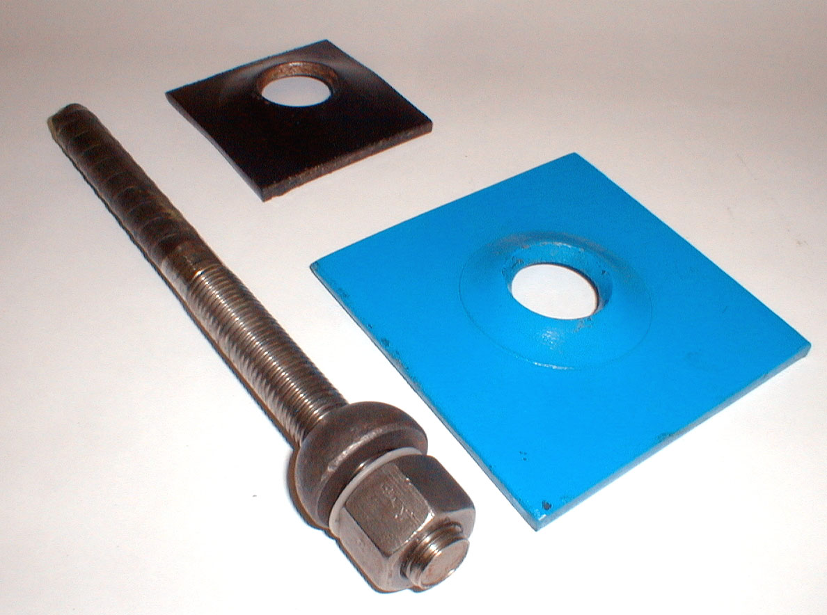

The following material shall be used.

a) Roof bolts Material : Torque Steel /M.S

(IS 1786:1985/1S/226/1S-1570)

Rod length : 1.5m minimum

Rod diameter : 20-22mm (ribbed bar)

Length of thread : 125-150mm.

b) Bearing Plate (IS: 225-1975)

Material : MS

**34**

Size : 150x150 mm or equivalent.

Thickness : 6mm

c) Nut (IS: 1363, part-3, 1984)

Shape : Hexagonal

Height : 20mm

d) Cement capsules shall be of following specifications:

Length : Not exceeding 400mm.

Diameter : 30-32mm

**PREVENTIVE MAINTENANCE**

The importance of preventive maintenance cannot be over emphasized. It not only forestalls trouble by regular checking and servicing of the machine, but also locates small defects and by rectifying them immediately, avoids major repairs and costly downtime.

The following points will help provide a longer working life for your machine.

1. Always check the machine when starting your shift.
2. Remove stones and dirt from the tracks and deck of the machine.
3. Tighten any loose bolts or nuts at once.
4. Check the fluid level in the header tank and top up if necessary.
5. Make regular checks on the hydraulic fluid filter indicator and clean the filter immediately it is shown dirty. Before cleaning the filter again it is advisable to pump out all dirty fluid and replenish with new.
6. At all times use clean containers for all oils used on the machine.
7. Do not run the machine with a low fluid level as this can damage the pumps.
8. Check all hydraulic hoses and connections for leaks or damage. Tighten or replace any leaking hose at once.
9. Never use a smaller bore hose than the one which was originally fitted to the machine.
10. All hydraulic hoses and fittings which are disconnected must be sealed off with suitable plugs or clean rag. Dirt is a hydraulic system’s biggest problem. Keep it clean.

**35**

1. Do not cut out safety features on the machine; they are for protection.
2. Check the traction gearbox oil levels regularly and make sure that water is not entering into the gearboxes (if applicable).

In most wet conditions the water is heavily contaminated with stone dust and this can act as a grinding paste at soil seal housings, eventually allowing water to leak into the gearboxes and cause expensive damage.

1. Grease all pins and bushes often and well. It is better to grease too much rather than too little.
2. Adjust the track to suit the working conditions.
3. Keep the machine as far as possible from the blasting area to prevent damage. Blasting damage can be very expensive in repairs and is due to the machine being left unprotected near to the blasting area.
4. Clean down the machine at regular intervals to permit a thorough examination. Loose bolts and fittings and hydraulic fluid and lubrication leaks can then be easily seen.
5. Report excessive wear or damage immediately and have this rectified as soon as possible.
6. Always keep the discharge point for the leader as close to the muck pile as possible. The shorter the distance the machine has to travel the less wear takes place and most important more muck is shifted.
7. Stop the machine if anyone is approaching, trying to pass by, or in a position where they could be run down.
8. Lubricate in accordance with the instructions issued for the machine.

**SAFETY PRECAUTIONS**

1. The equipment should be kept in good working condition and regularly checked for safe operation.
2. The equipment shall not be operated otherwise than by a competent person appointed to be the driver of the equipment.
3. Always lower the bucket to the ground when the machine is not in motion. A raised bucket is the machine.

**36**

1. Pull the dump valve lever (if equipped) and push button station into the “off” position to isolate the machine.
2. Turn the machine towards the side of the working & check the tracks if the machine is left standing on a gradient.
3. Check the track chain and maintain in good condition at all times.
4. Replace all weak, broken or missing springs which center the hydraulic control valves in the neutral position. These springs are important safety features and hence your machine should not be used if they do not function correctly.
5. Never use the control levers as a hand hold while climbing on the machine.
6. Never service the loader or make adjustments when the machine is running.
7. Never allow anyone to stand beside the machine while the machine is running.
8. Except with the permission no person other than the operator shall be on SDL when it is in motion.
9. Do not use SDL as a transporting vehicle and for pushing & pulling the bulky materials.
10. Use only correct size & type of cable.

**Points to be noted:**

1. Keep the roadways smooth and clear for free movements of machine.
2. Do not stretch the cable over against corners of pillars.
3. Do not allow cable over ridden by tracks of machine or damaged otherwise.
4. Do not operate machine with higher or very low pressure than recommended.
5. Keep the ventilation adequate enough to take way the heat from working area of machine. Recommended ventilation 0.6 m/sec. speed or 0.8 m3/min. per H.P. whichever is better on the roadways on which machine is working.
6. Equipment operation speed shall be consistent with conditions of roadways, grades, clearance, visibility and traffic.
7. Road condition shall be suitable and maintained for hauling purpose.
8. Machines shall not be operated on gradient exceeding their permitted by regulations

37

Environmental Compliance of the Narwapahar Mine

During initial period of underground mine development, waste rock was transported to the surface. An area of 6.18 ha has been earmarked for waste dump site within mine lease. Out of total, only 1.12 ha area has been used for waste dumping. At present entire waste which is generated during mining activity is being used for void filling in underground. Presently waste rock is not transferred to the dump site. Action has been taken for progressive reclamation of used area of the dump site in phased manner. In first two phases, the waste dump was leveled and terraced with top soil. The steep slope of the dump has been managed less than 28 degree and proper compaction was insured for better stability. Top soil of 30 cm thick has been used to cover the waste. Grass turfing has been done on the slope for protection against soil erosion. Garland drain with settling pond of the capacity 800 m and conveyance system has been constructed to capture the runoff water from waste dump area. The collected water is used for industrial purpose as a part of water conservation practice. Greenbelt has been developed around the area with indigenous species. Plantation will continue along the periphery and on top of dump in phase manner. The treated sewage is used for reclamation of waste dump and watering of the plants.

Topic:6

**RADIATION HAZARDS**

In a uranium mine the workers are exposed to the hazards of radiation in addition to the other hazards of underground mining operations. Two main sources of health hazards are inhalation of radon gas and airborne dust. To minimize the effects of radon, the mine must have a good ventilation system, so that all radon gas generated is flushed out of the mine and the working places are well ventilated. With this in view, powerful ventilation fans are installed and are kept running. Auxiliary fans are installed wherever they are necessary.

For suppressing dust, all operations in the mine where there are chances of raising dust are made wet operations with sprinkling of water. All drilling operations in the mine are wet and in all places where ore is handled, water is sprinkled to keep the dust down. **38**

Monitoring of radiation, radon and dust is done by the **Health Physics Group** of the Bhabha Group of Bhabha Atomic Research Laboratory at Narwapahar. Members of this laboratory take samples from the mine and mill sites at periodic intervals and keep a watch on all aspects of radiation. The results of the investigation conducted at Environmental Survey Laboratory at Narwapahar show that the exposure to radiation is below the permissible limits of 5 rem per year.

**DETECTORS**:

**GEIGER MULLER COUNTER:** This consists of an evacuated glass tube filled with a mixture of argon and ethyl alcohol at a low pressure. There is a wire in the centre of the tube which acts as an anode and the coaxial cylinder acts as the cathode. The application of a high voltage of the order of 1000V across the electrodes establishes an electric field. The gamma rays are intercepted by the cathode and resulting interaction produce ionization in the tube and small electrical signals are produced.

**SCINTILLATION COUNTER:** This consists of a thallium activated sodium iodide crystal and an electronic device called photo multiplier tube. Whenever a gamma ray passes through the crystal, a part of the energy of the ray is absorbed in the crystal. This absorbed energy produces excitation in the crystal resulting in small spaces of light called scintillations. These are picked up by the photo multiplier tube, which in turn produces small electrical signals. Thus both the above detectors convert the gamma rays into small electrical signals. Since these signals are too small, they are amplified and shaped to equal amplitude pulses by means of electronic circuits. These signals can be counted directly by an instrument called scalar, or converted into a current, which is measured by a counting rate meter. Thus for any measurement, a detector, a high voltage supply and a scalar or a counting rate meter are essential.

**39**

**HEALTH AND PHYSICS UNIT**

Uranium (U), chemically reactive, radioactive metallic element that is the main fuel used in nuclear reactors. Uranium never occurs naturally in the Free State, but is found as an oxide or complex salt in minerals, such as pitchblende. Pure uranium consists of several isotopes, among which U238, the maximum producing element is very common in nature. The presence of odourless, lustureless uranium is only identified from the ray radiation that is emitted by antimony, bismuth, the daughter element of U, considering secular equilibrium. That’s why; the physicists have to use several instruments to measure the concentration of radon gas and to detect the uranium.

**RADON COUNTING SYSTEM**: The photomultiplier tube, Lucas cell are used in this system. The inner wall of that cell is located by zinc sulphide which acts as α-radiation detector. At the time of radon decay, α emits and that interact with zinc sulphide. Resultantly, the electron of last cell changes its state. It becomes excited, when it jumps down to the ground level, the photons come out, and voltage pulse is generated. The numbers of pulses are measured in circuit of photomultiplier tube. From the number of counts, the concentration of radon is calculated.

If concentration of air increases, the number of radon increases. The unit of radon concentration is Becquerel/m3. It may be 1000bq/m3 in maximum. Above this limit, it has an harmful effect on environment.

**ALPHA COUNTING SYSTEM**:The dust which is generated due to blasting of ore also contains radioactive uranium, thorium, and radium. This dust is exhausted by fan or by using the water, it can also be reduced. The radioactive dust particles, having 5 microns in size, are very much harmful for our respiratory system. Particles having size more than that can’t go inside. At the same time, though the particles, having the size less than 5 micron can easily go inside, but it can also come out through mucus.But, the Particles of that particular size, damages our lungs-radiates ,β ,γ- rays inside the body. That’s why the machine that counts the dust particles of that size is required. A filter paper, having permissibility of 0.15 bq/m3 is used in this system.

**40**

**FLOUROMETER**:This machine is for detection of uranium, in any environmental sample. It works in flour sense technique and measures the wave of proton in ppm, or in microgram/kg.There is a platinum disc in the machine. The liquid sample material is put there drop by drop. It is a chemical process.

**PUMP**:It is used for pumping out the air from the scintillation cell*.*

**PROGRAMMEBLE RADON COUNTING SYSTEM**:It follows the same principles of detection as the radon counting system does.

**ENVIRONMENTAL RADON DOSIMETER**: The machine having gigar Muller tube is used for measuring the γ- ray radiation- ray is measured in micro roentzen/hr. Generally, it should be 50-400mR/hr in an underground mine. In Narwapahar mine it is 100-200 mR/hr. The safe limit is considered as 800Mr/hr. Above this limit, it is harmful.

**LOW LEVEL RADON DETECTION SYSTEM***:* It works for electrostatic detection .The procedure is as follows:-

* First, the evacuation is done by using pump.
* Then, providing high negative voltage (-800volt) to the chamber, a 5lit. Air cylinder is added with it.
* The s.s plate will put inside the counting set up in the next step.
* The system is thus kept for 90min.
* After that, radon is pumped out.
* Finally, by using this count, the actual radon concentration, where we have collected the sample is calculated.

The machine is used here as it has an ability to measure even the smallest concentration of radon (upto4bq/m3).The concentration of radon is measured in bq/m3.

**41**

**PERSONAL DUST SAMPLER**: It is used for measuring the concentration of dust

in air. It is measured in mg/m3.The flow rate is 1.9 lit/min i.e. this much of air is sucked to measure the dust in air. A filter paper is used in this system, the permissibility of which is 0.8 mg/m3.

Beside the above, there is also LUX METER, TOXI METER, SOUND LEVEL METER.

**SOLVENT EXTRACTION METHOD**: It is used for separation of uranium and to measure the content of uranium in water, soil etc. It measures in mg/kg unit.

**Topic:7**

**Reference:**

<https://environmentclearance.nic.in/writereaddata/Online/TOR/09_Oct_2017_193044543TEYA70Q8PFR_NarwapaharMine.pdf>

<https://ucil.gov.in/pdf/NIT%20No.NWP-668.pdf>

<https://ucil.gov.in/pdf/myth/Mining,%20milling%20&%20tailings%20disposal-best%20practices.pdf>

<https://environmentclearance.nic.in/writereaddata/Online/EDS/19_Apr_2018_1059355330Q1963YFADS.pdf>

**42**